My Three-Month Climate Action Plan 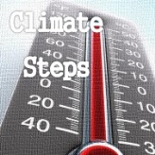
Name: _____________________________________

Mentor Name: _________________________________________

Chosen Focus Theme: ________________________________________
(See left, and then see www.climatesteps.org for different steps per theme, some still being beefed out.)
Type of Action | Description |  | What’s Needed (skills, people, time….) | Deadline | Potential Impact | Actual Impact (Brag about it!)
Community
Individual
Political

